Benchmark Problem #1
The experiments chosen for this benchmark were conducted at the O. H. Hinsdale Wave Research Laboratory at Oregon State University to measure the debris movement and tsunami inundation over an unobstructed beach in a directional wave basin (DWB). The debris consisted of rectangular plywood boxes and were placed unconstrained on a flat section raised above the basin floor with no still water on the raised section. An image processing technique was developed for measuring the position and orientation of multiple debris specimens using a unique color scheme for the box lids. Seven model configurations were tested based on three main characteristics, including the number of boxes, the induced rotation, and the segmentation of groups. The combination of wire resistance wave gauges (WGs) and ultrasonic wave gauges (USWGs) were used to capture the free surface information. For Kinematic Trials, the USWG4 was collocated with an acoustic-Doppler velocimeter (ADV2). Complete details of the experiment can be found in the accompanying journal paper:
Rueben M, Cox D, Holman R, Shin S, Stanley J. Optical measurements of tsunami inundation and debris movement in a large-scale wave basin. Journal of Waterway, Port, Coastal, and Ocean Engineering. 2015 Jan 1;141(1):04014029.
The following figure shows the schematic diagrams of the seven box configurations used in the experiments; white boxes are free to move along the floor and gray stationary box is fixed. For this benchmark, we will focus on configurations 1, 3, 4, and 12.
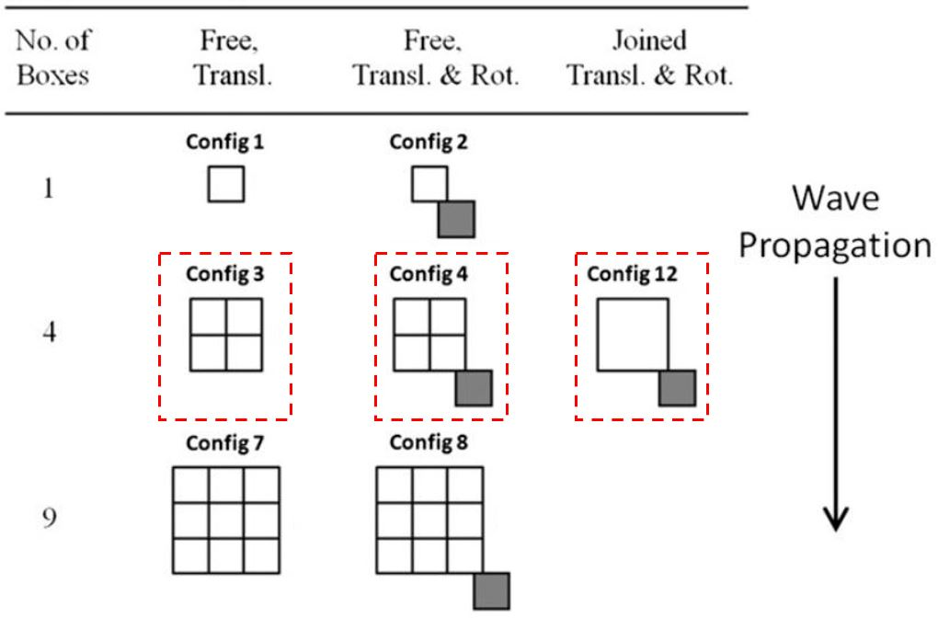
Figure 1. Schematic diagrams of the seven box configurations

EXPERIMENT SETUP:
- Basin: Rectangular shape with the dimensions of 48.8 m long, 26.5 m wide and 2.1 m high. Beginning at the wavemaker, the bathymetry was comprised of a constant depth section for 0 m < X < 10 m at Z=0 m followed by a 1:15 slope for 10 m < X < 17.5 m, followed by a 1:30 slope for 17.5 m > X > 32.5 m and ending with a raised flat section through X=43.75 m at elevation Z=1 m above the basin floor (Fig. 2, elevation view). The impermeable bathymetry was constructed of smooth concrete with a float finish, and the roughness height was estimated to be 0.1–0.3 mm.
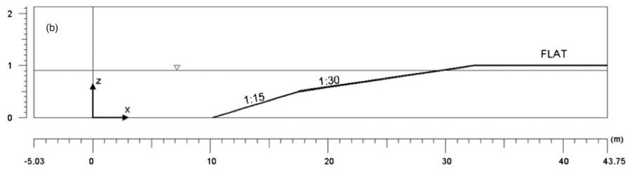
Figure 2. Elevation view of the basin including sections depth and slope
- Box size: Each box has a nominal footprint of 60 cm by 60 cm and is 40 cm tall (not a perfect cube).
- Box material properties: The debris specimens were constructed from 12.7-mm (0.5-in.) thick plywood. Nominal dry weights were 14.5 kg (+/-1 kg) per box. The coefficient of friction between the wet plywood debris and smooth concrete floor of the basin was not measured and is estimated from the literature to be in the range of 0.2 to 0.3.
- Water depth @ Wavemaker: 90.56 cm
- Incident Wave: The generated wave for this problem is not a solitary wave. It is custom wave meant to maximize the stroke of the wavemaker, while generating a long period wave. Note that due to this generation approach, the wave is not permanent, like a solitary wave. Numerically, the wave can be generated using two different methods:
1) The wavemaker displacement time series can be used if a moving wall boundary condition is available in the numerical model.
2) The time series of incident wave elevation at WG2 can be used to force the numerical model at X=2.26 m.
Both of these time series can be seen and plotted using the " incident_wave.m" script in the "wave_generation" directory (see image below).
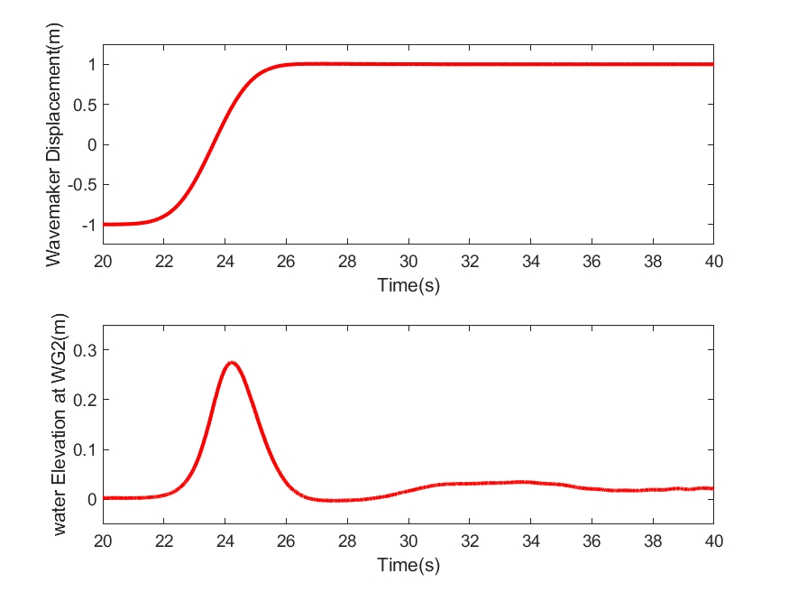
Figure 3. Wavemaker displacement time series (top) and WG2 elevation (bottom)

Benchmark Data (in directory "comparison_data")
The following data should be compared with the numerical model output.

Free surface elevation data at WG2, WG6, usWG3, and usWG4
This data is contained in the directory “wave” and can be plotted with the script “load_wave_data.m”. The location of the wave gage is shown below (see also included journal paper). Note that there is other data included in the “raw_data” directory as well. Modelers may compare with any data they wish, but please be sure to show comparisons at these four wave gages. Comparisons at these particular locations will be used to ensure that the generated waves in the model are reasonable, in terms of amplitude, period, and arrival time.

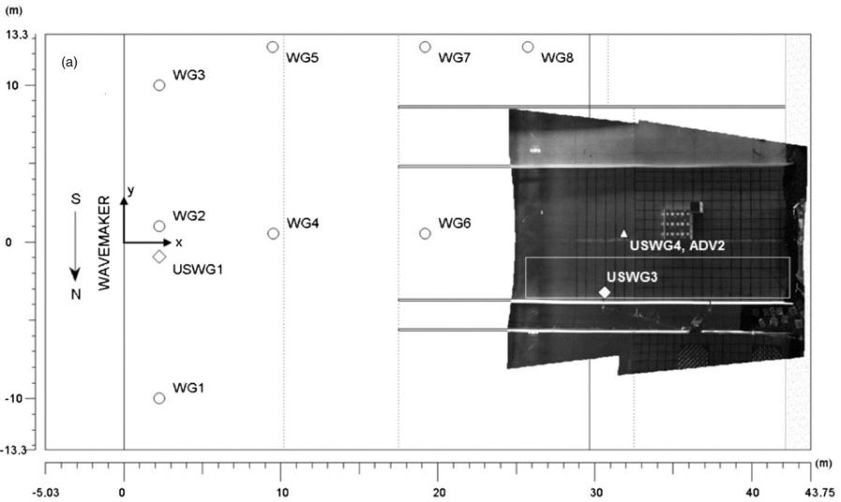
Figure 4. Basin plan view including locations of the gauges and the velocimeter

Table 1. Instrument locations (wave gauges and velocimeter)

Instrument | Instrument description | x (m) | y (m)
WMDISP | Wave maker displacement | - | 0.00
WG2 | Resistive wave gauge | 2.26 | 0.98
WG6 | Resistive wave gauge | 19.22 | 0.56
USWG3 | Ultrasonic wave gauge | 30.68 | -3.20
USWG4 | Ultrasonic wave gauge | 31.89 | 0.54
ADV2 | Acoustic-Doppler velocimeter | 31.89 | 0.54

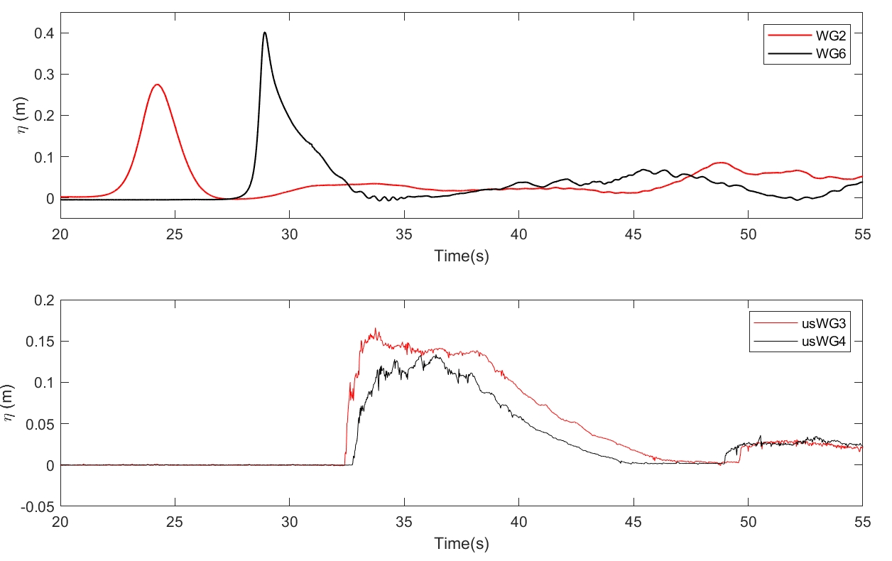
Figure 5. Water level at WG2 and WG6 (top) and usWG3 and usWG4 (bottom). Note that there is a discrepancy with these data as plotted in the Rueben et al paper. The data in the paper were scaled; the plots above show the data as measured in the lab.

Velocity data at ADV2
The ADV2 data is also plotted with the “load_wave_data.m” script. Due to the bubbly nature of the flow, there is limited available velocity data at this location.

Path positions and cross-shore (X-direction) velocities
This data comparison is the primary task of this benchmark exercise. Here, modelers should compare path positions and cross-shore (X-direction) velocities for box configurations 3, 4, and 12 (Figure 1). Data for these locations can be plotted with the script "load_configs.m" in the directory “paths_and_velocities” and are shown below in Figures 6 (particle path positions, or traces) and 7 (cross-shore velocity time series). Note that there is data for other configurations as well (in "raw_data"). Modelers may compare with any data they wish, but please make comparisons for configurations 1, 3, 4, and 12 the priority.

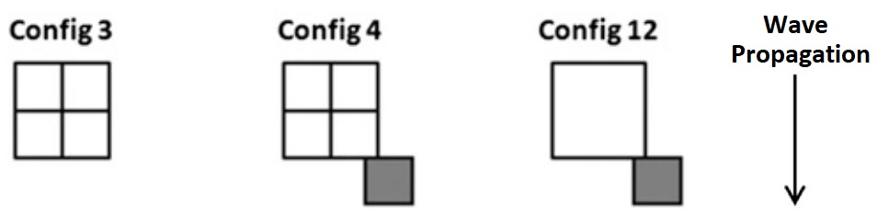
Figure 6. Schematic diagrams of the box configurations 1, 3, 4, and 12

Path positions and cross-shore velocities for multi box configurations (Configurations 3 and 4) are for the centroid, which is the arithmetic mean of all box centers. For Configurations 1 and 12 these values are for the center of the single box. The initial centroid for Config 1 is [x,y]=[34.64 m, 0.52 m], and the initial centroids for the other configurations are all [34.94 m, 0.82 m]. If modelers are interested in the paths and velocities of the individual boxes for Configurations 3 and 4, that data can be found in the “raw_data” directory.

Modelers are to provide comparisons with the centroid path positions and cross-shore velocity time series for the four configurations. Modelers are encouraged to discuss various parameter changes used during the comparisons, such as grid size, time step, friction, breaking models, material properties, and any initiation and stopping thresholds for debris motion.

Note that the "load_configs.m" script also generates a simple ASCII text file for each configuration, with columns: time (sec); x-position (m); y-position (m); cross-shore velocity (m/s), and it may be easier to use these files for your model comparisons.

We ask that each modeler provide a similar ASCII data file for their numerical predictions, and send to Lynett. This can be done before or during the workshop, but all results will be combined during the summary discussion.
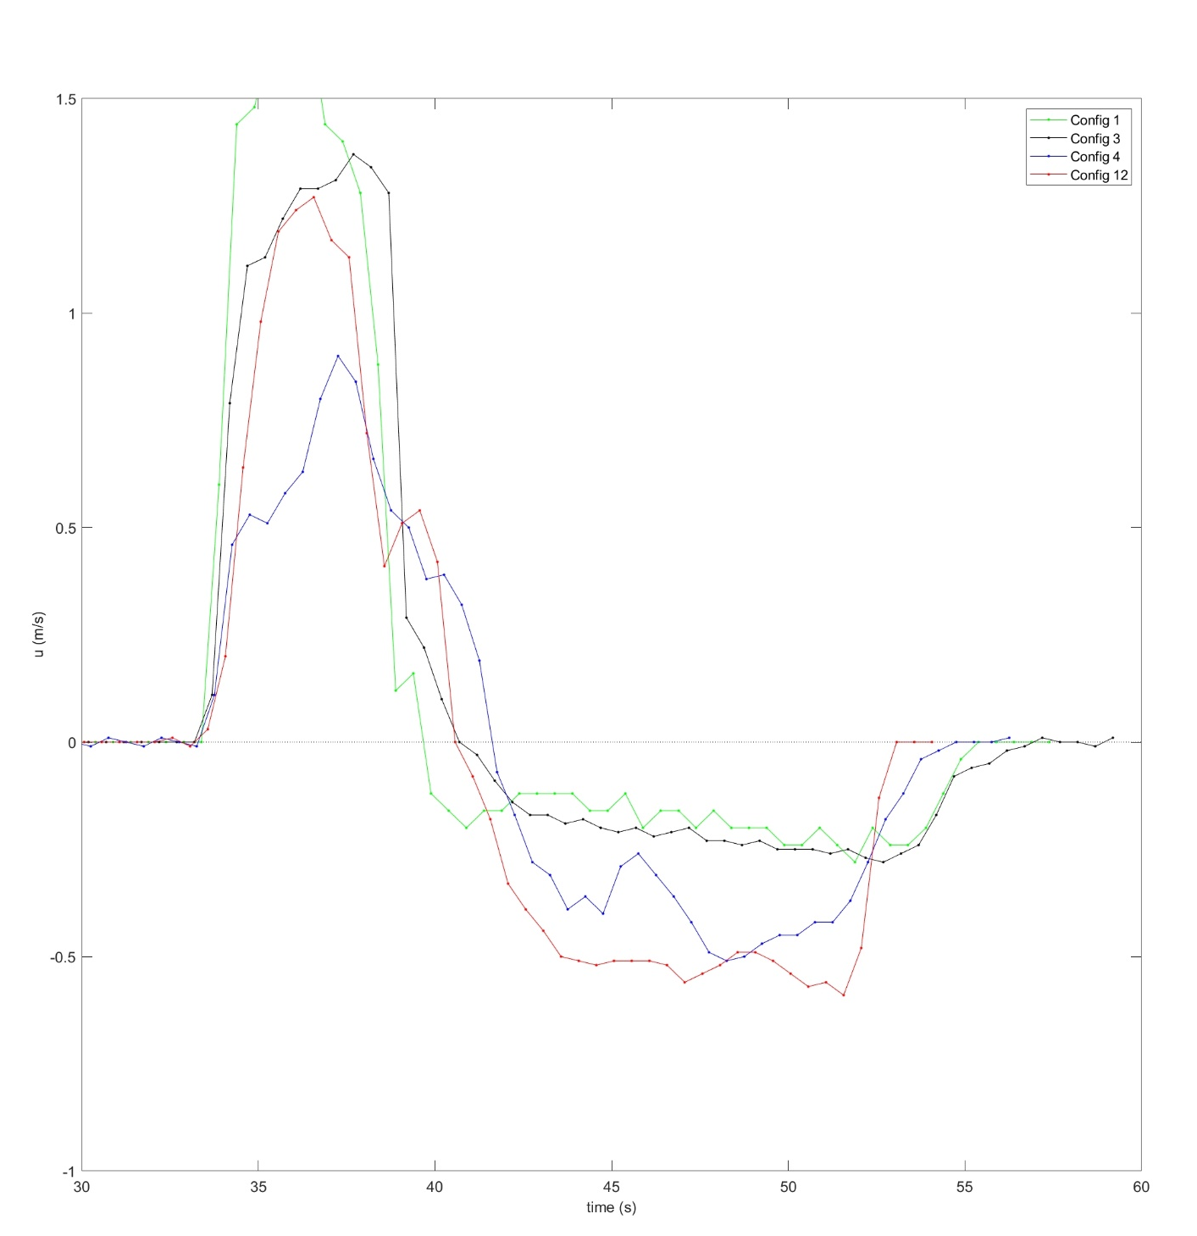
Figure 6. Cross-shore velocities for configurations 3, 4, and 12

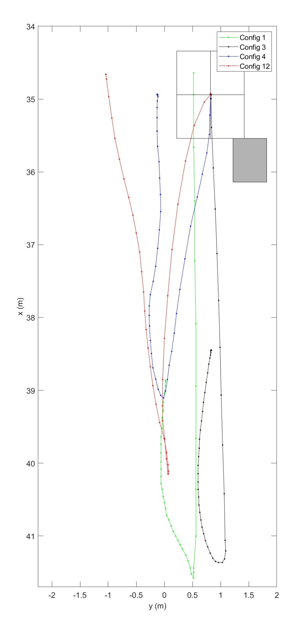
Figure 7. Path positions for configurations 3, 4, and 12

