Benchmark Problem #2
The experiments chosen for this benchmark were conducted at the O. H. Hinsdale Wave Research Laboratory at Oregon State University to measure the debris movement and tsunami inundation over an unobstructed beach in a directional wave basin (DWB). The debris consisted of rectangular wood and HDPE boxes and were placed unconstrained on a flat section raised above the basin floor with no still water on the raised section. An image processing technique was developed for measuring the position and orientation of multiple debris specimens using a unique color scheme for the box lids. The combination of wire resistance wave gauges (WGs), ultrasonic wave gauges (USWGs), and ADV’s were used to capture hydrodynamic information. Complete details of the experiment can be found in the accompanying journal paper:
Park, H., Koh, M.J., Cox, D.T., Alam, M.S. and Shin, S., 2021. Experimental study of debris transport driven by a tsunami-like wave: Application for non-uniform density groups and obstacles. Coastal Engineering, 166, p.103867.

The following figure shows scale and number of particles used for these experiments. The different color debris indicate different materials (wood or HDPE), and trials were run with and without obstacles (white boxes in Figure).
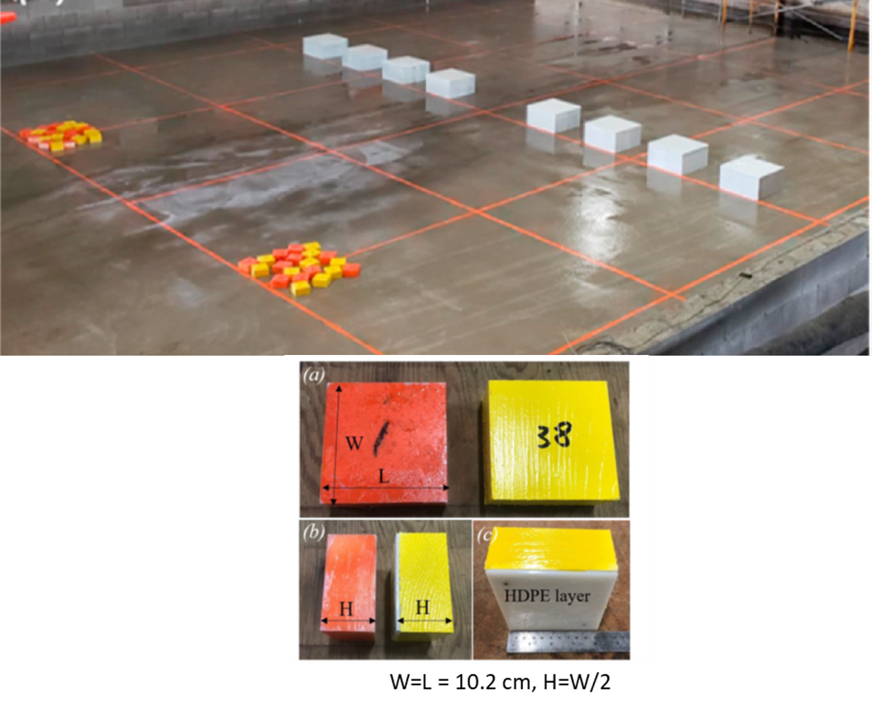
Figure 1. General layout of the Park et al. trials (top) and different types of debris (bottom)

EXPERIMENT SETUP:
- Basin: Rectangular shape with the dimensions of 48.8 m long, 26.5 m wide and 2.1 m high. Beginning at the wavemaker, the bathymetry was comprised of a constant depth section for 0 m < X < 11.29 m at Z=0 m followed by a 1:20 slope for 11.29 m < X < 31.29 m, and ending with a raised flat section through X=41.29 m at elevation Z=1 m above the basin floor (Fig. 2, elevation view). Note that the back-end of the flat, shelf-section ends into a drainage basin at X=41.29 m, so this boundary is best modeled as an outgoing boundary, rather than a vertical wall. The impermeable bathymetry was constructed of smooth concrete with a float finish, and the roughness height was estimated to be 0.1–0.3 mm.
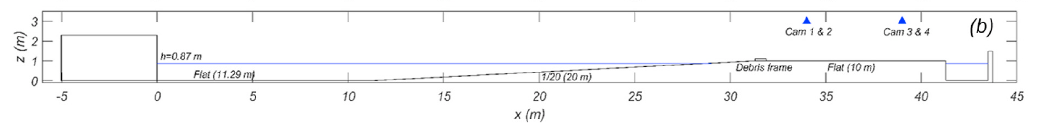
Figure 2. Elevation view of the basin including sections depth and slope
- Box size: Each box has a nominal footprint of 10.2 cm by 10.2 cm and is 5.1 cm tall (not a perfect cube).
- Box material properties: Two types of debris (HDPE and Wood) used in this test (Fig. 1). The measured mean density of HDPE (orange color) and Wood debris (yellow color) were 987 (11.7) kg/m3 and 648 (17.6) kg/m3, respectively, after painting, with the standard deviation of density in parenthesis. Both HDPE and Wood debris utilize the same bottom by adding HDPE layer. However, the averaged static friction coefficient (at almost dry condition) and standard deviations under the test conditions were μ_{s} = 0.66 (0.07) for HDPE and μ_{s} = 1.28 (0.13) for Wood, with the standard deviation in parenthesis. For wet conditions, the measured static coefficient of HDPE was 0.38 and Wood was 0.71.
- Water depth @ Wavemaker: 0.87 m
- Incident Wave: The generated wave for this problem is not a solitary wave. It is custom wave meant to maximize the stroke of the wavemaker, while generating a long period wave. Note that due to this generation approach, the wave is not permanent, like a solitary wave. Numerically, the wave can be generated using two different methods:
1) The wavemaker displacement time series can be used if a moving wall boundary condition is available in the numerical model.
2) The time series of incident wave elevation along the wavemaker paddle can be used to force the numerical model at X=0 m. Note that this is not ideal, as the wavemaker paddle is moving in time; however there is no wave gage data available in the flat section of the basin near the wavemaker.
Both of these time series can be seen and plotted using the " incident_wave.m" script in the "wave_generation" directory (see image below).
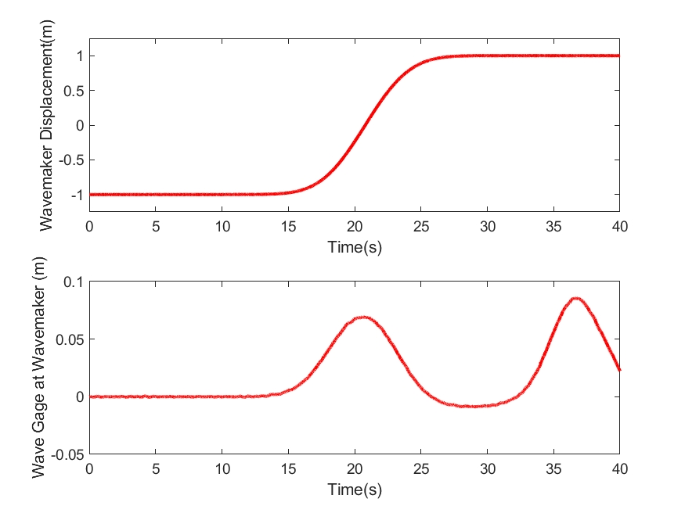
Figure 3. Wavemaker displacement time series (top) and wavemaker wave gage (bottom)

Benchmark Data (in directory "comparison_data")
The following data should be compared with the numerical model output.

Free surface elevation data at WG1, WG9, usWG5, and usWG_{h}5
This data is contained in the directory “wave” and can be plotted with the script “load_wave_data.m”. The location of the wave gage is shown in the Figure and Table below (see also included journal paper). Note that there is other data included in the “raw_data” directory as well. Modelers may compare with any data they wish, but please be sure to show comparisons at these four wave gages. Comparisons at these particular locations will be used to ensure that the generated waves in the model are reasonable, in terms of amplitude, period, and arrival time. Note that modelers should only be concerned with capturing the initial wave in these data. Due to the very long wave generated, and the breakwaters in the side channels, reflected wave energy arrives at the wave gages about 10 seconds after the crest of the leading wave; the entire offshore section of the basin is sloshing. These reflected waves do not play a significant role in the debris motion.

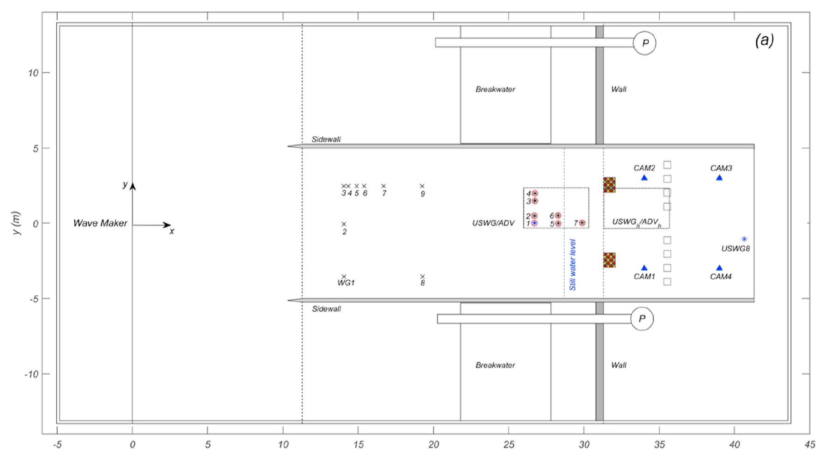
Figure 4. Basin plan view including locations of the gauges and the velocimeter

Table 1. Instrument locations (wave gauges and velocimeter)

Instrument | Instrument description | x (m) | y (m)
WMDISP | Wave maker displacement | - | 0.00
WMWG | Wave maker wave gauge | - | 0.00
WG1 | Resistive wave gauge | 14.05 | -3.54
WG9 | Resistive wave gauge | 19.25 | 2.5
USWG5 | Ultrasonic wave gauge | 28.30 | 0.00
USWGH5 | Ultrasonic wave gauge | 35.53 | 0.00
ADVH5 | Acoustic-Doppler velocimeter | 35.53 | 0.03

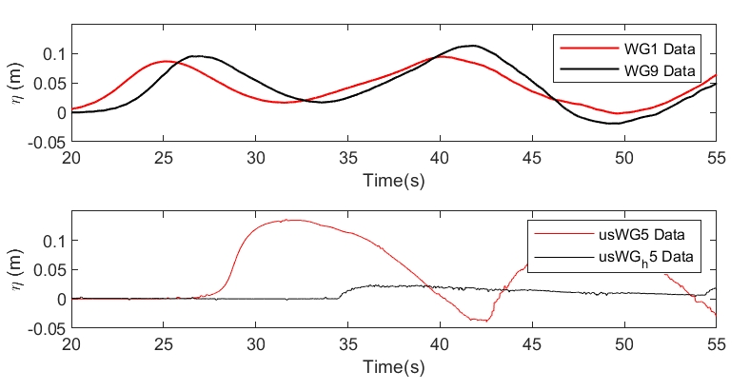
Figure 5. Water level at WG1 and WG9 (top) and usWG5 and usWGH5 (bottom).

Velocity data at ADVH2
The ADVH5 data is also plotted with the “load_wave_data.m” script. Due to the bubbly nature of the flow, there is limited available velocity data at this location.

Statistics of Final Debris Locations
There will be four cases of debris motion included in this benchmark.
- Case 1: Array of HDPE Boxes. An array of 5 boxes wide by 4 boxes long is placed as shown in Figure 6. In this image, the waves approach from the bottom of the frame. The boxes are spaced 5.1 cm apart in both the x and y directions. The offshore edge (bottom side of image) of the boxes is at X=31.29 m.
- Case 2: Array of Wood Boxes. Identical initial configuration as Case 1.
- Case 3: Random array of 10 HDPE and 10 Wood boxes. The boxes are placed randomly in space and individual rotation, as shown in Figure 7. Numerous experimental trials for this case were run, all with different initial placements of the random array. The debris boxes are initially placed inside of a wood frame (71.4 cm by 56.1 cm) without an overlap among debris, as shown in Figure 7.
- Case 4: Same initial debris configuration as Case 3. Figure 8 provides the position of the two obstacles (white boxes). The size of an obstacle (W by L by H) is 0.4 m by 0.4 m by 0.3 m. Obstacles are made of concrete and firmly fixed on the ground. The space between two obstacles is 0.4 m. The exact coordinate of the left bottom edge of the left obstacle (green dot in the figure) is x = 35.29 m, y = -0.6 m.

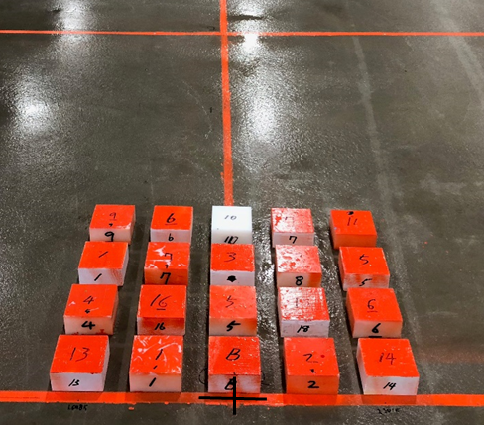
Figure 6. Initial debris array layout for Cases 1 and 2

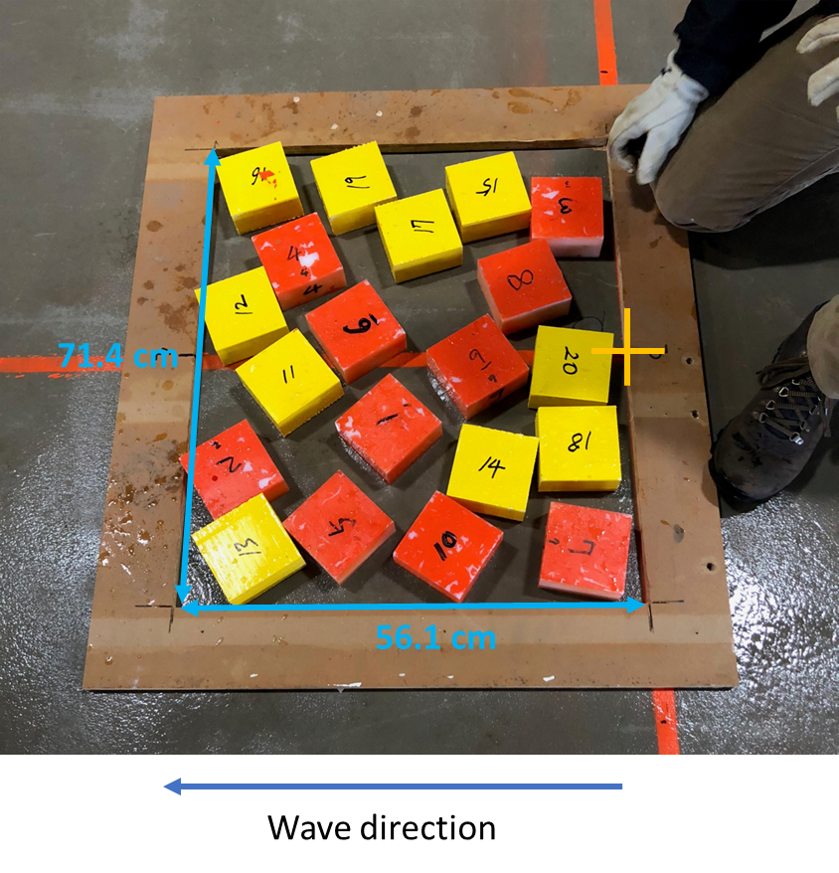
Figure 7. Initial debris array layout for Cases 3 and 4

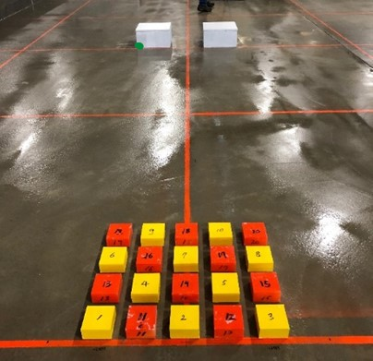
Figure 8. Obstacles for Case 4. Note that Case 4 uses the random array of particles, not the ordered layout shown here.

Numerous experimental trials have been run for each of these Cases.

In order to compare a set of metrics across models, we will use statistical measures of the final debris “cloud” location. Data for the individual particle time-history of motion is not available. The final spread of the particles will be described by:
- Mean cross-shore distance traveled – particle-mean x-distance traveled, taken from the centroid x-coordinate of the initial debris field, or X=31.57 m
- Lateral spreading – standard deviation of the final y-positions of the particles
- Longitudinal spreading – standard deviation of the final x-positions of the particles
The data for Case 1 and Case 2 is included in the “debris_locations” directory, and can be plotted with the Matlab script “plot_Case12_data.m.” The output from that script is given in Figure 9. Data for Cases 3 and 4 will be provided at the workshop.

Modelers are to provide comparisons with mean distance traveled, the lateral spreading, and the longitudinal spreading. Modelers are encouraged to discuss various parameter changes used during the comparisons, such as grid size, time step, friction, breaking models, material properties, and any initiation and stopping thresholds for debris motion.

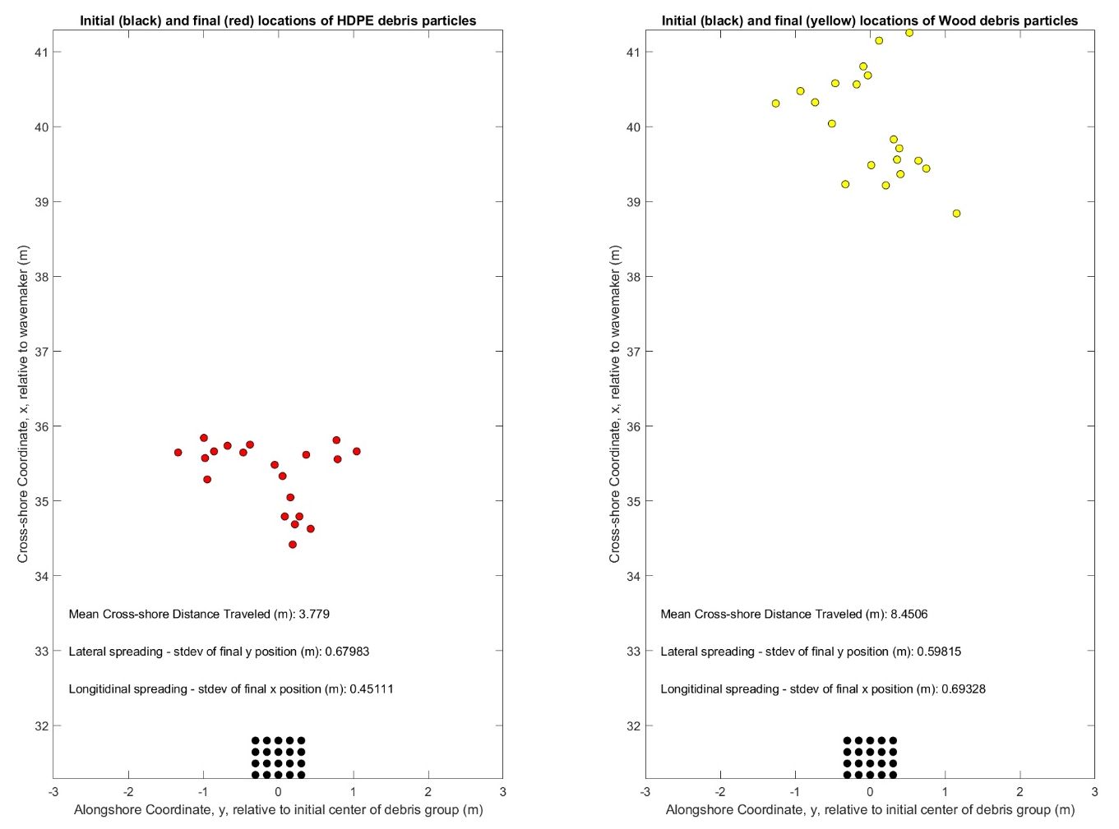
Figure 9. Final positions and statistics for Case 1 (left) and Case (2) right.

