Benchmark Problem #3
This benchmark problem examines the transport of large objects by complex flow through a urban environment. The goal was to measure debris movement of a small number of large particles by complex 2D flow. The debris consisted of 3d-printed boxes and were placed in two different locations. A single, very-long-period wave crest was generated, and the debris was allowed to move through an urban layout. The debris consisted of boxes and were placed unconstrained at two different locations. An image processing technique was developed for measuring the position and orientation of multiple debris specimens using a unique color scheme for the box lids. Wave gauges (WGs) are used to describe the incident wave. Complete details of the experiment can be found in the accompanying journal paper:
Chida, Y. and Mori, N., 2023. Numerical modeling of debris transport due to tsunami flow in a coastal urban area. Coastal Engineering, 179, p.104243.

The following figure shows scale and particle locations used for these experiments. The two different debris locations were run separately, each with 10 trials. A single debris particle was placed in the model for each trial.
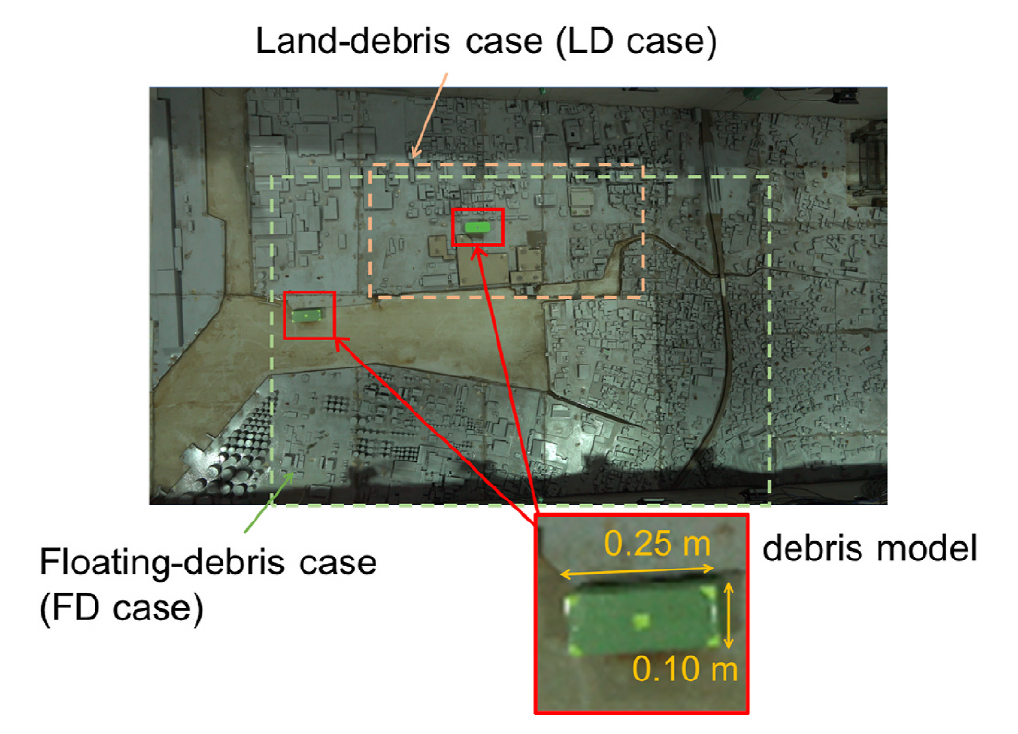
Figure 1. General layout of the Chida and Mori experiments, showing two different debris initial locations

EXPERIMENT SETUP:
- Basin: Rectangular shape with the dimensions of 20.4 m long and 4.0 m wide. Beginning at the offshore boundary, the bathymetry was comprised of a constant depth section for -12.4 m < X < -7.84 m with depth of 0.877 m followed by a 1:10 slope for -7.84 m < X < 0.0 m, and ending with the city model for 8.0 m of length. (Fig. 2, elevation view). Note that the back-end city model section ends into a drainage basin at X=8.25 m, so this boundary is best modeled as an outgoing boundary, rather than a vertical wall. The impermeable city model was constructed of wood. The bathy/topo data can be loaded with the “load_bathy.m” script in the “city_bathytopo” directory.
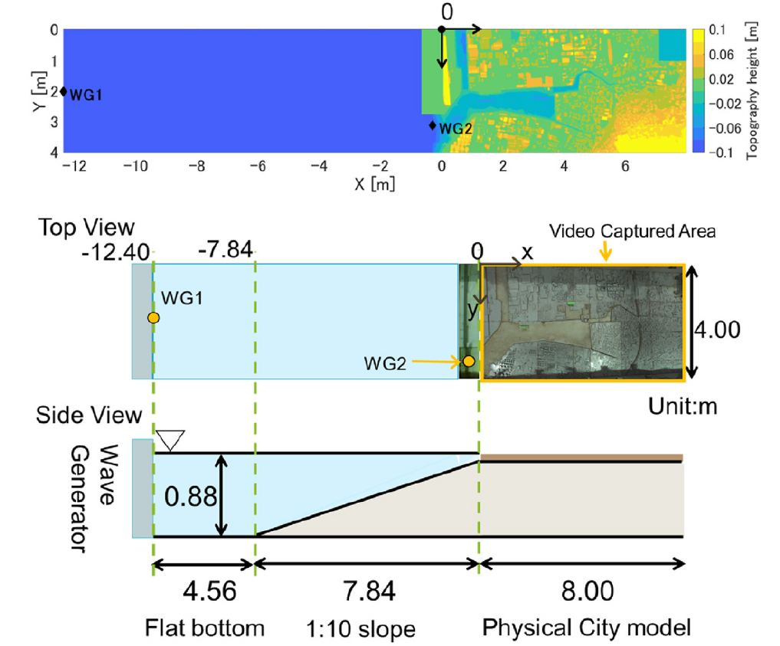
Figure 2. Elevation (top and middle) and side (bottom) view of the basin including sections depth and slope
- Box size: Each rectangular box has a nominal footprint of 25 cm by 10 cm and is 10 cm tall.
- Box material properties: The debris objects were made by using 3D printer with raw material PLA resin. The specific gravity of the objects is 0.25.
- Water depth @ Wavemaker: 0.877 m
- Incident Wave: The generated wave for this problem is not a solitary wave. It is custom wave generated through pumping water into the offshore end of the wave basin, creating a long period wave. Numerically, the wave can be generated using two different methods:
1) The pump inflow can be distributed along the offshore boundary. The constant pumping discharge was 0.035 m³/s. The pump was turned on at t=0s, and turned off at t=300 seconds. After 300 seconds, there is no pump inflow, and the water leaves the basin through the drainage channel behind the city model.
2) The time series of incident wave elevation can be used to force the numerical model at X=-12.4 m. Note that this time series, measured in the dataset WG1, contains the incident wave, the reflection off the City model, the re-reflection off the wavemaker, and so on. Thus, the WG1 data represents an offshore water level condition, not an incident wave.
The WG1 time series can be seen and plotted using the "loadWG.m" script in the "wave_generation" directory (see image below). This script will load all the measured time series at the WG1 location, from the 20 combined debris trials. Modelers should use the mean value of these trails to drive and compare their models. The mean WG1 time series can be found in the text file “eta_WG1.txt”, with associated time vector in “t_WG.txt.”
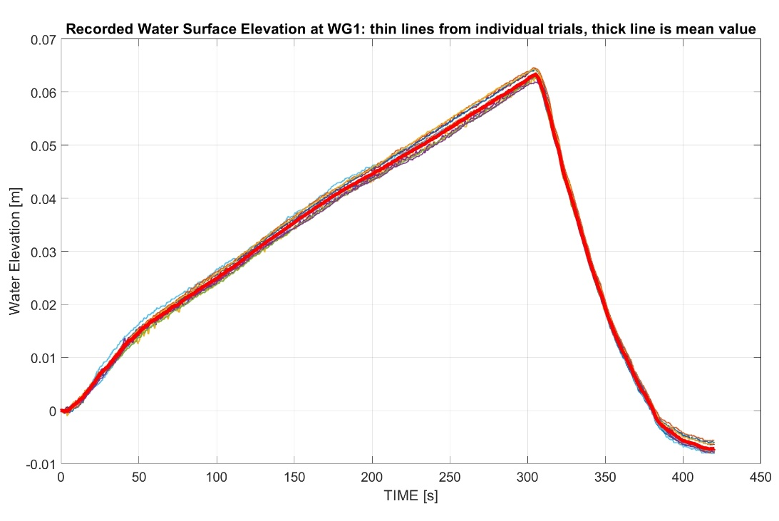
Figure 3. WG1 time series

Benchmark Data (in directory "comparison_data")
The following data should be compared with the numerical model output.

Free surface elevation data at WG1 and WG2
This data is contained in the directory “"wave_generation” and can be plotted with the script “loadWG.m”. The location of the wave gage is shown in the Figure and Table below (see also included journal paper). Note that there is no other hydrodynamic data specific to this set of experimental trials. Comparisons at these particular locations will be used to ensure that the generated waves in the model are reasonable, in terms of amplitude, period, and arrival time.

Figure 4. Basin plan view including locations of the gauges and the velocimeter

Table 1. Instrument locations (wave gauges and velocimeter)

Instrument | Instrument description | x (m) | y (m)
WG1 | Resistive wave gauge | -12.4 | 2.0
WG2 | Resistive wave gauge | -0.30 | 3.0

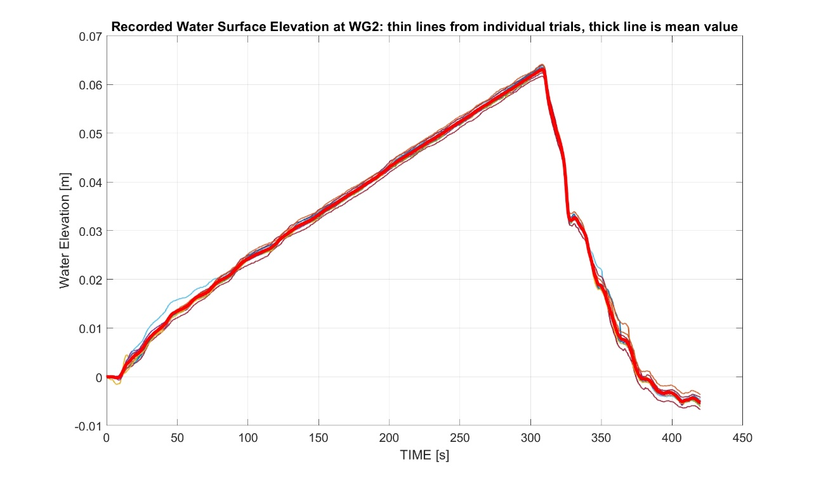
Figure 5. Water level at WG2

Statistics of Debris Trajectories
There will be two cases of debris motion included in this benchmark.
- Case FD (initially Floating Debris): A single debris box initially placed with centroid at X=1.37 m and Y=2.15 m
- Case LD (initially Land Debris): A single debris box initially placed with centroid at X=2.94 m and Y=1.26 m
The initial locations of debris for these two cases are shown in Figure 6.

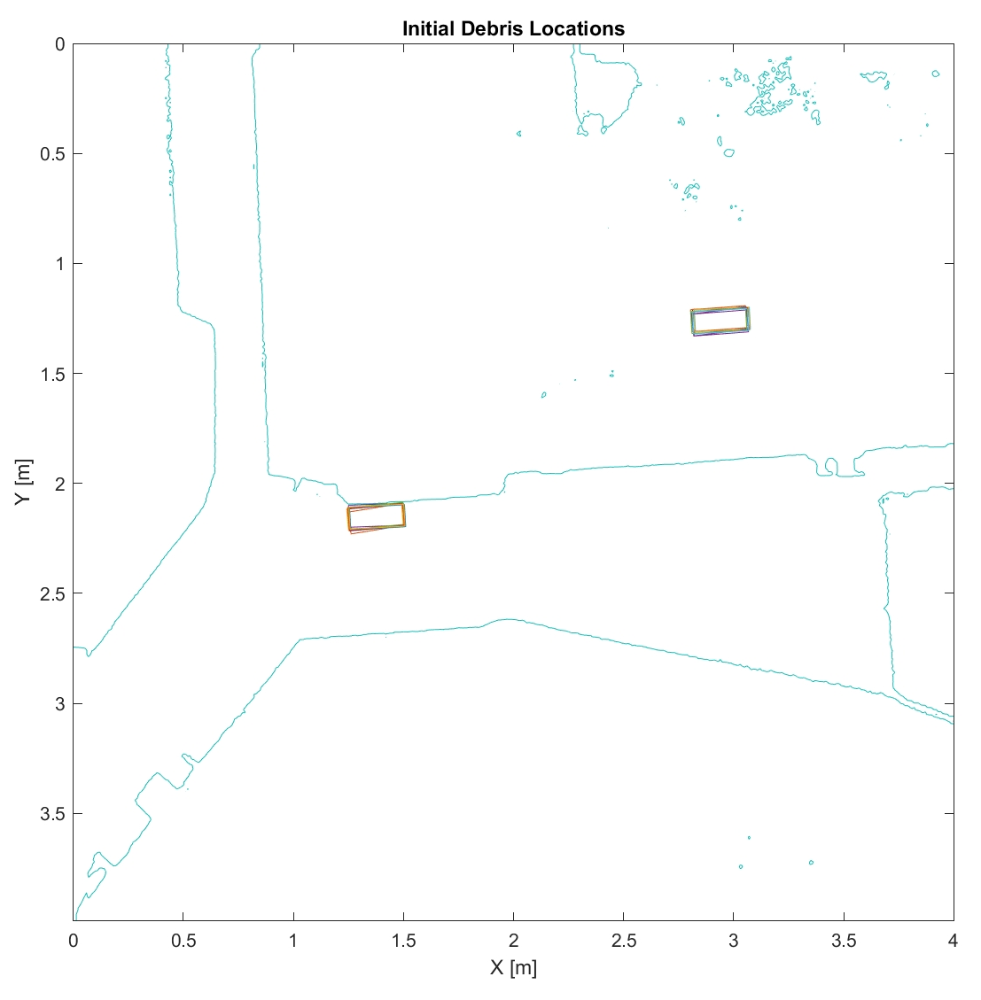
Figure 6. Initial debris array layout for Cases FD (left box location) and LD (right box location)

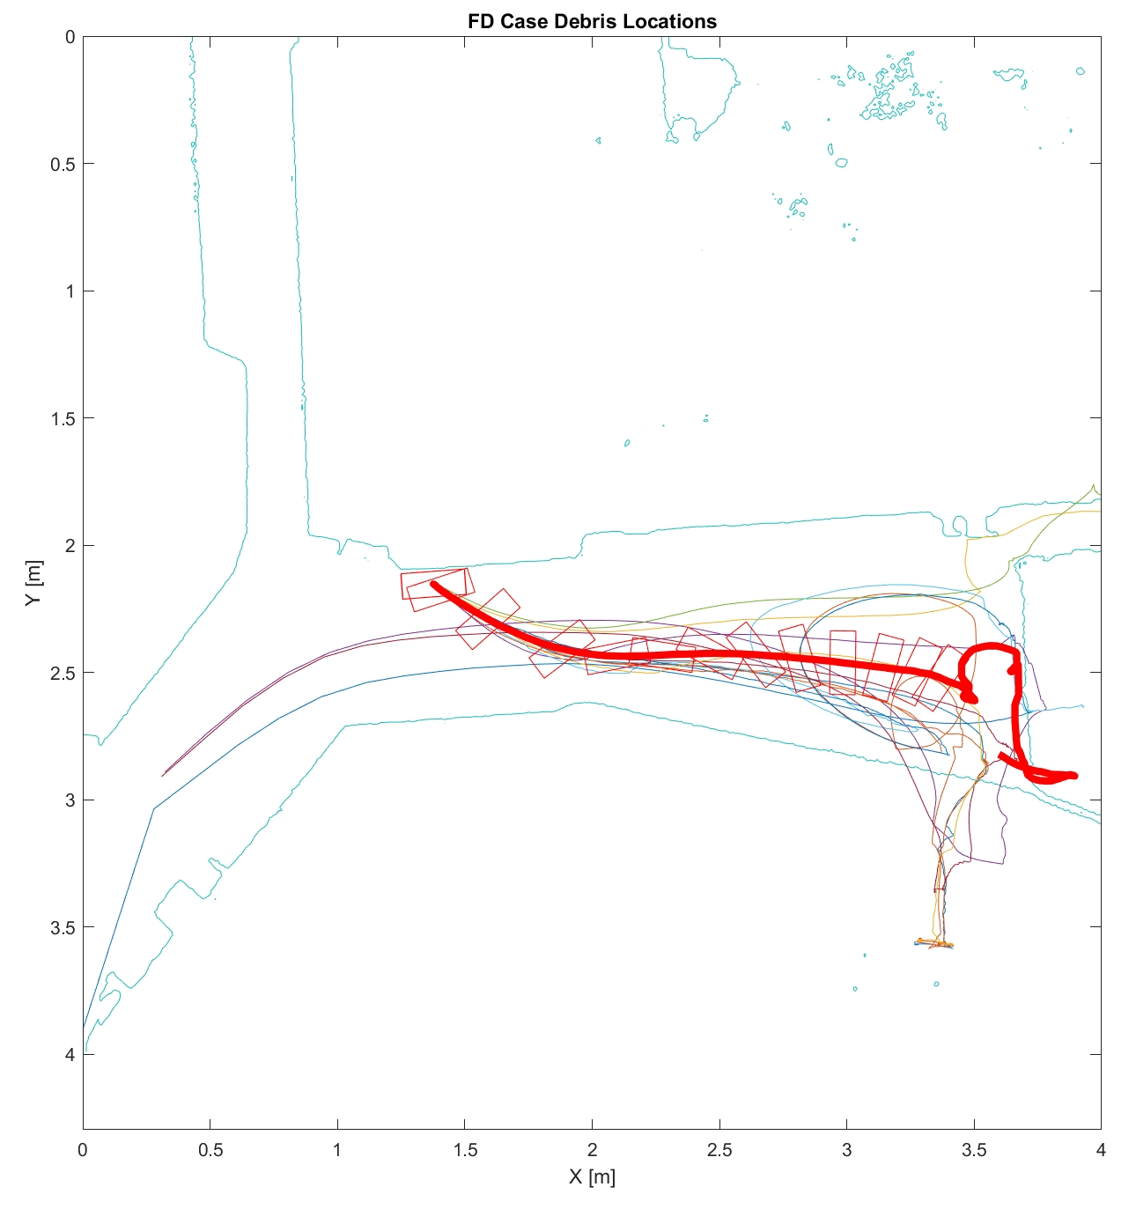
Figure 7. FD debris trajectories. The thin colored lines are the trajectories from the 10 trials, while the thick red line is the mean trajectory, plotted for ~300 seconds. The mean debris orientation is shown as well, at 5 second intervals. Note that some of the debris ends in the lower right, some in the upper left, and some gets transported offshore.

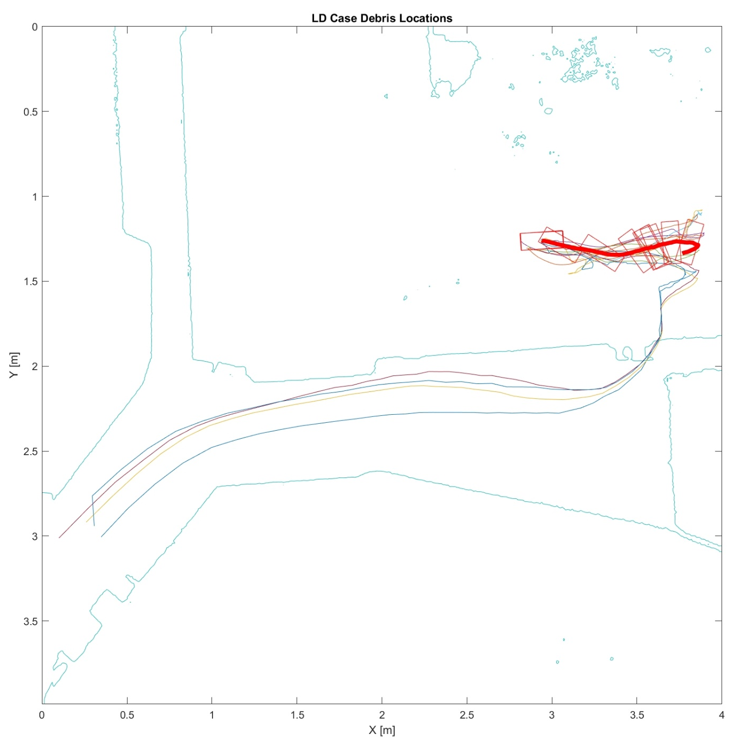
Figure 8. LD debris trajectories. The thin colored lines are the trajectories from the 10 trials, while the thick red line is the mean trajectory, plotted for ~300 seconds. The mean debris orientation is shown as well, at 10 second intervals. Note that some of the debris ends in to the right, and some gets transported offshore.

10 experimental trials have been run for each of these Cases. The 10 individual trajectories, as well as the mean trajectory are shown for each Case in Figures 7 and 8. Note that while the mean trajectory is plotted, there are “families” of trajectories, particularly at later times. In Case FD, in some trails the debris motion terminates in the lower right of the figure, while another set is taken offshore. Similarly, in Case LD, some of the debris stops moving inside the city to the right of the initial location, while in four of the trials, the debris is taken offshore. While modelers will compare with the mean trajectory of the debris for early times, capturing this bi- or tri- (or many but finite) furcation of likely debris trajectories is also of interest.

In order to compare a set of metrics across models, we will use statistical measures of the debris trajectories. The trajectories of the debris in the two Cases will be described by:
- X-position of the debris centroid as a function of time
- Y-position of the debris centroid as a function of time
- Debris rotation angle as a function of time
The data for Case FD and Case LD is included in the “comparison_data” directory, and can be plotted with the Matlab script “load_trajectories.m.” The position times series data are plotted in Figures 9 and 10. Included in this directory are ASCII files of the position time series. In each of these files, for example LD_Yposition.txt, the first column is time, the second column is the mean value, the third column is the standard deviation from the 10 trials, and the 4th-13th columns are the values from the 10 individual trials.

Modelers are to provide comparisons with the X, Y, and rotation angle time series for the first 300 seconds. It is expected that good agreement with the experimental data may only be possible for the first ~100 seconds of motion for each case. After this time, the variance in the debris position becomes very large, and it is not possible to know if the physical model is capturing the magnitude of this variance with 10 trials. Modelers are encouraged to discuss various parameter changes used during the comparisons, such as grid size, time step, friction, breaking models, material properties, and any initiation and stopping thresholds for debris motion. In particular, modelers are encouraged to discuss the statistical behavior of their transport predictions after the first ~100 seconds of motion.

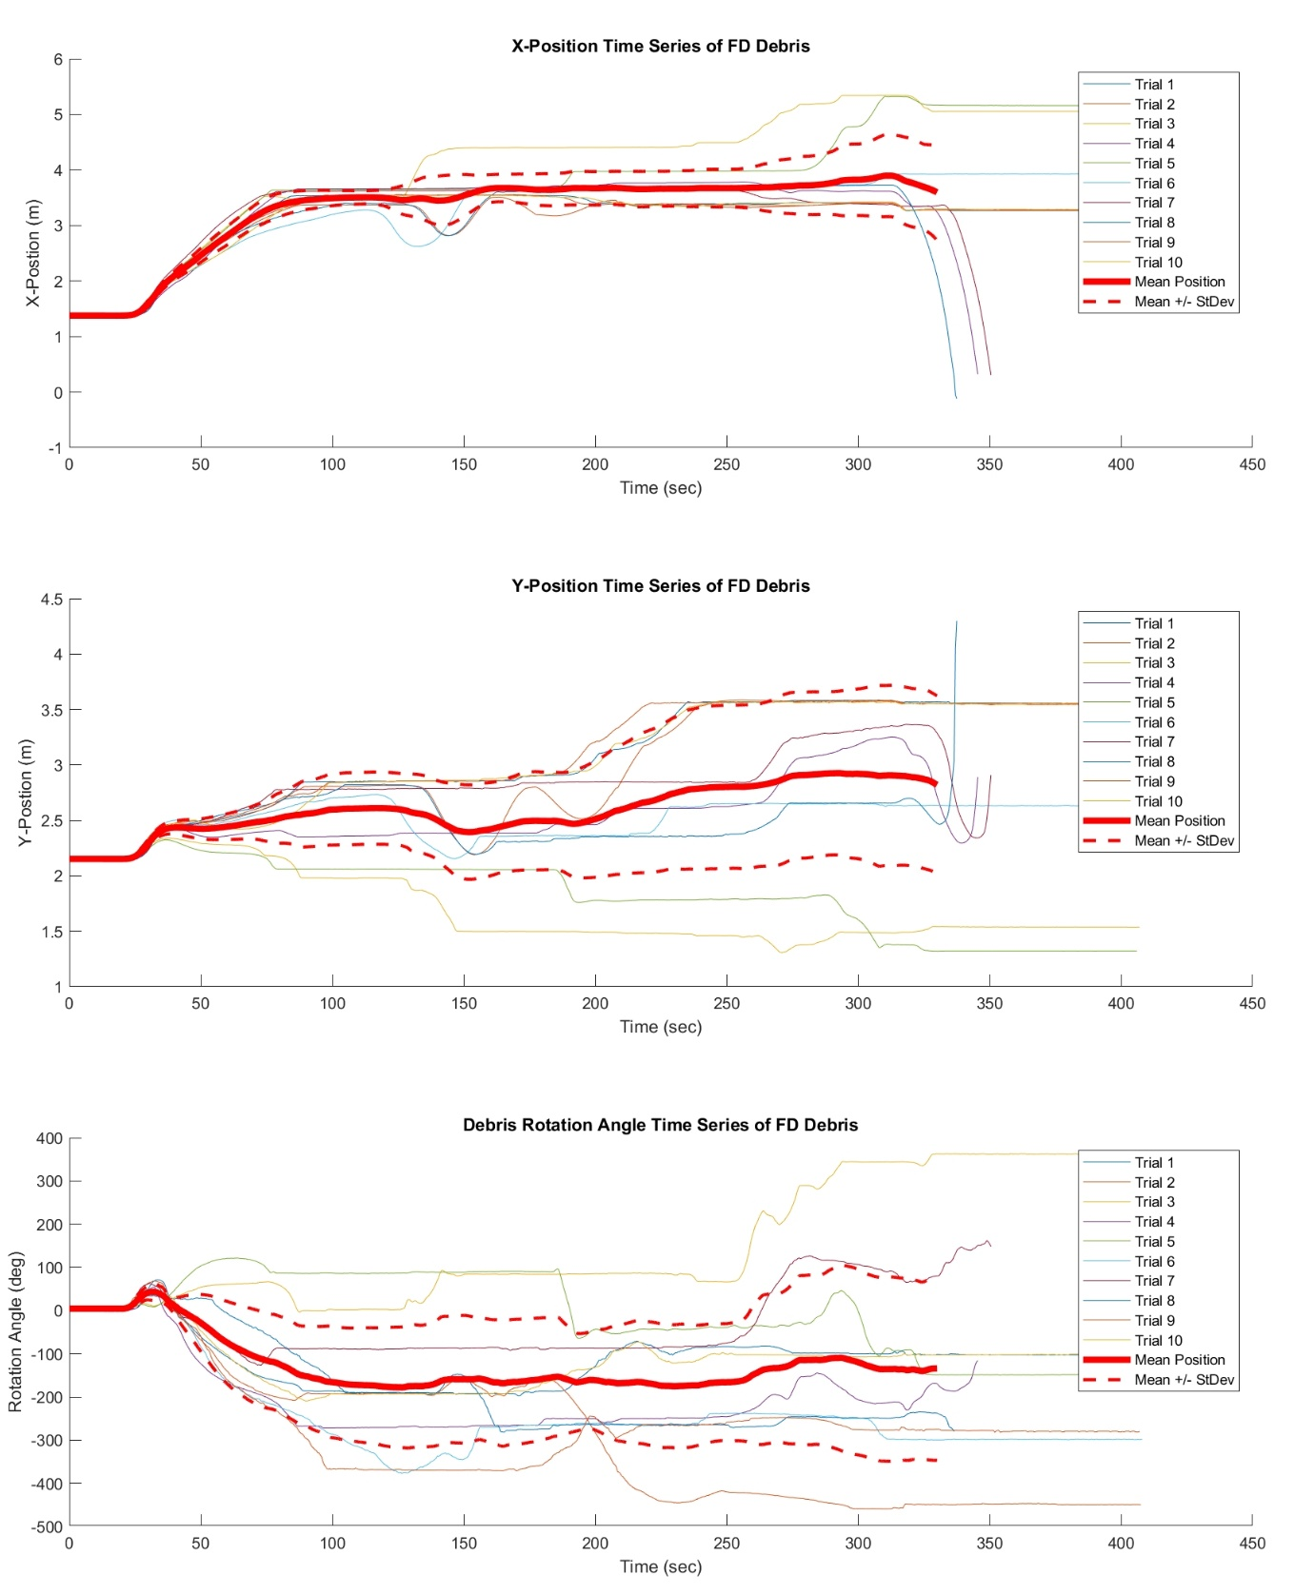
Figure 9. X-position (top), Y-position (middle), and rotation angle (bottom) time series for the FD Case. In each subplot, the thin lines are the values from the 10 individual trials, the thick red line is the mean value, and the dotted red line is the mean +/- the standard deviation.

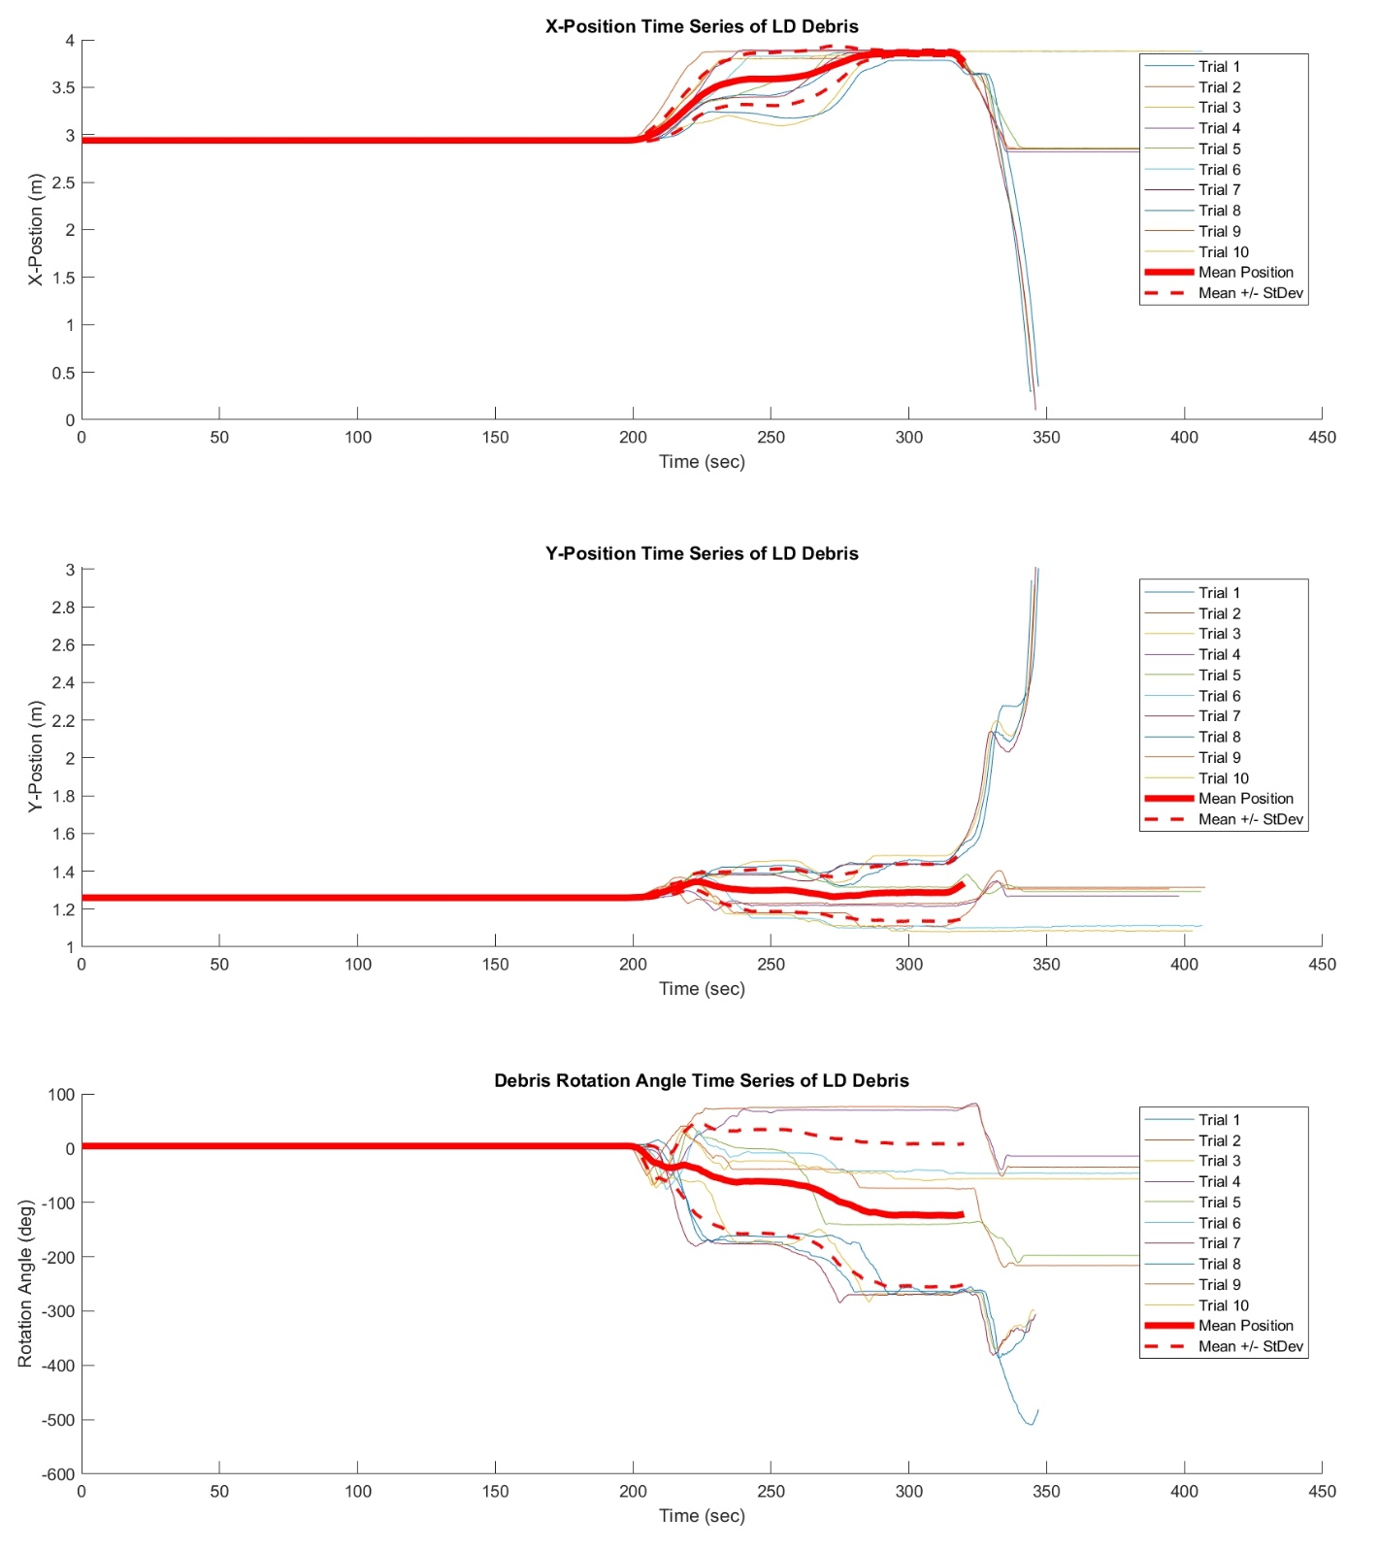
Figure 10. X-position (top), Y-position (middle), and rotation angle (bottom) time series for the LD Case. In each subplot, the thin lines are the values from the 10 individual trials, the thick red line is the mean value, and the dotted red line is the mean +/- the standard deviation.

